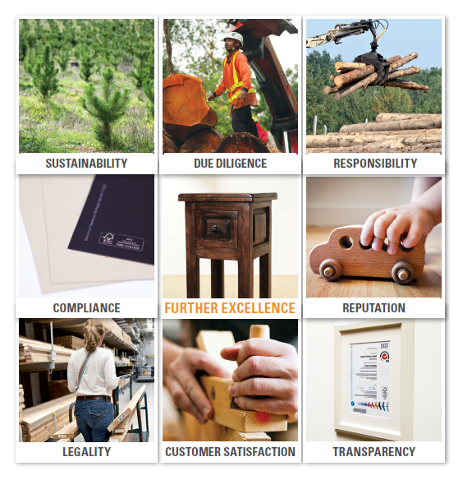
HOW CAN YOU REASSURE YOUR CUSTOMERS ABOUT THE ORIGINS OF YOUR WOOD & PAPER PRODUCTS?
Chain of Custody Certification - Application Form

SGS is the world’s leading inspection, verification, testing and certification company. We are recognized as the global benchmark for quality and integrity. With more than 97,000 employees, we operate a network of more than 2,600 offices and laboratories around the world.
Our world-leading certification services enable you to demonstrate that your products, processes, systems or services are compliant with national and international regulations and standards.
Forestry product Chain-of-Custody (CoC) certification enables you to demonstrate that the wood you trade or use comes from well-managed forests or other controlled sources.
Forest, Timber and Paper Certification contacts and Accreditations:
FSC™ Forest Products Chain-of-Custody (CoC) Standard and Certification SGS
https://
www.sgs.com/forestryaccreditations

Information about the Organisation
Organization name:
Legal registration N°:
(if applicable)
Address:
City/Country: |  | Post code:
Telephone:
Person in charge: |  | E-mail:
Web site:

Reference to Standard and Audit Type
FSC  PEFC  SFI  Project Certification (indicate standard)  Other*  * Please specify: ……………………… | Initial Audit  Re-assessment  Extension of scope / Change in scope  Certificate transfer (Provide detail below)  Others (Please detail it):

Total number of Employees
All the personnel involved in the certification scope, including all shifts, non-permanent employees (sub-contractors, temporal, and seasonal) and part-time employees. The total number of employees must be calculated as the equivalent number of full-time employees, according to the working hours.

Scope of the Certification
Explain the processes* and products which will be included in the certificate below.
* If useful for clarification, please attach a flow chart of the relevant processes
Please tick the control method(s) implemented in your Chain of Custody system: | Transfer System / Physical Separation Method  Percentage System / Method  Credit System

 |  | Kind of Operations
 | 1 | Purchase and sales of certified products through direct shipment – without any physical product handling (e.g. Direct merchant, trader, broker or distributor)
 | 2 | Purchase and sales of certified products; including physical product handling (warehousing, storage, distribution), but without processing or manufacturing (e.g. Paper distribution merchant, lumber dealer)
 | 3 | Conversion of paper products (e.g. Cutting to size, sheeting, manufacturing of envelopes)
 | 4 | Printing and publishing
 | 5 | Primary wood product manufacture utilizing systems to separate and segregate certified materials (e.g. Sawmills, pulp/paper mills not utilizing credit accounting, percentage-based, or mixed-source systems).
 | 6 | Primary wood product manufacture utilizing systems that include “controlled/non-controversial sources” and systems for percentage-based or credit-based product claims (e.g. Sawmills, pulp/paper mills utilizing credit-accounting, threshold-based or mixed-source systems).
 | 7 | Secondary wood product manufacture utilizing systems to separate and segregate certified materials (e.g. Lumber-treatment, millwork, furniture, etc.; not utilizing credit accounting, threshold-based, or mixed-source systems).
 | 8 | Secondary wood product manufacture utilizing systems that include “controlled/non-controversial sources” and systems for threshold-based or credit-based product claims (e.g. Lumber-treatment, millwork, furniture, etc.; utilizing credit-accounting, threshold-based or mixed-source systems).
 | 9 | Utilization and/or sale of recycled wood products for use with certified claims (e.g. FSC-recycled label)
 | 10 | Logging

Input Material Categories
FSC 100%
FSC Mix
FSC Recycled
FSC Controlled Wood
Controlled for FSC (uncertified and risk assessment must be conducted)
Recycled material
100% PEFC material
PEFC percentage-based material
SFI
Non-controversial wood / Material for PEFC (risk assessment must be done)
Recycled material to be used in PEFC product

Outsourcing of Processes
Outsourcing: The practice of contracting an internal business process (i.e. activities or tasks that produce a specific service or product) to another organization. Outsourcing activities usually take place outside the organization’s facilities. The organization may establish outsourcing agreements with other companies operating within its facilities when the organization has no control or supervision over the activities performed by the contractor. E.g. cut, laminated, manufacturing |  |  |  |  | NO | Yes
If your organization outsources processes in the certification scope, the following information is required to assess site visit requirements. Please include additional charts if necessary:
Subcontractor | Address | Type of service | % services use | Certification of subcontractors

Use of Non-Certified Material (Controlled Wood, Controlled Sources)
Are you using any NON-certified (1) raw material for the production of certified products?  For example if some components of the final product are not available as certified or if the company doesn’t have any option to identify and segregate the certified and non-certified material before starting, or during, the production.  If your answer is yes, you must present the DDS summary. Please contact your local SGS affiliate for an explanation of this process.  Due diligence system (DDS): A system of measures and procedures to minimize the risk of sourcing material from unacceptable sources. A DDS contains the following three elements: obtaining information, risk assessment, and risk mitigation (when needed)  Risk assessment: An assessment of the risk of sourcing material from unacceptable sources, including risk related to origin and mixing material in supply chains. |  |  | NO | YES
If your organisation is sourcing uncontrolled or uncertified material, SGS require the following information to assess the need to visit related sites. Please include additional charts if necessary.
Number of suppliers (if this varies, provide average) | Number of countries/districts where suppliers are located | Are any suppliers rated as “Unspecified Risk” for FSC Controlled Wood?

Use of Recycling Material
Are you using recycled raw material for the production of FSC / PEFC / SFI certified products? |  | NO | yES
- What type of reclaimed material is being is used as input? |  | Pulp and Paper | Wood
- Can material be identified on receipt as pre- or post-consumer material? |  | NO | yES
If mark “Wood” and “Yes” in a) and b) is ticked, please submit the following additional information:
Supplier name | Address | Raw material used (description)

Multiple Sites
Do you intend to cover more than one site in your certification scope?  (Please provide additional information if necessary) |  |  | NO | yES
If your answer is yes, please provide information about applicable system
Multi-site | Group scheme | Single certificate with multiple sites
Information about sites (add more lines here or provide information in a separate document):
Site Name | No of Employees | Site scope
Important: the different sites must perform similar activities, have a legal contract with the head office, and be part of a common management system controlled by the head office. The head office will keep the authority over all sites in terms of related documents and changes in the system, management review, complaints, corrective actions, internal audits as well as other requirements established in the standards.
fsc ACCREDITATION ANNUAL FEE (AAF)
The payment of the AAF is an FSC requirement and SGS collects the payment on behalf of FSC. This fee must be paid annually. It is based on the total turnover of the company for forestry products and all products which contain wood or its derivates (certified and non-certified material).
The AAF Policy will be reviewed annually and revised to remain consistent with any new FSC strategy and/or policy or account for inflation according to the global inflation rate of the previous year.
Please consult the FSC Website for actual information about recent AAF Policy (FSC-POL-20-005).
A turnover declaration will need to be completed and submitted as part of the audit.
https://fsc.org/en/for-businesses/annual-administration-fee
https://fsc.org/en/document-center
PEFC Notification Fees
- Turnover of the PEFC certified organisation PEFC notification fee – for forest related industries.
- In case of multi-site certification, the multi-site organisation’s turnover is calculated as a sum of the turnover of all sites included in that organisation.
- Notification fees may be changed in terms of requirements of the local PEFC Governing Body, as each PEFC Governing Body determines their own notification fees.
- A turnover declaration will need to be completed and submitted as part of the audit.
PEFC Annual Fees (charged by PEFC to SGS).
SGS will invoice you, this amount will appear as a line item
on the proposal we will submit to you. .
Number of Sites being certified | Annual PEFC Annex 4 Notification Fee – invoiced by SGS
1 | $500 /yr
2 – 20 | $1,000 /yr
21 - 40 | $5,000 /yr
41 + | $10,000 /yr

Additional information and signature
Please rate the maturity grade of your system *: | High | Medium |  | Low
* Please include the reason for your answer e.g. implementation dates, previous certification cycles, etc.
Have you received external consultancy?
Please provide the name of your consultant.
Is your company currently FSC, PEFC or SFI certified or has it been certified before by another certification body? |  |  | NO |  | YES
If your answer is Yes, please provide the certificate number and reason why certification has not been continued / wanting to change Certification Body.
Remark: For certificates withdrawn or expired less than 12 months ago, SGS will have to verify open nonconformities.
Please provide suggested audit dates
Please include any comment considered important for proposal preparation.

Authorized representative signature of the applicant:
Date:
Your time to complete this form is appreciated. Please submit the completed form to the local SGS affiliate to prepare a fee proposal.
All information provided is confidential.
The information provided in this form will be included in the SGS database and kept for commercial purposes. You will retain the right to withdraw this information. For any questions please contact your local SGS office.
Chain of custody process diagram: For improved understanding you may attach a flow-diagram of the process at your site. Please indicate all points where non-certified material could be mixed with certified material. SGS is required to understand the full system in order to submit an accurate proposal.
Detailed information about the certification requirements can be obtained on the following Websites:
FSC COC requirements: https://fsc.org/en/document-center
PEFC COC requirements: https://www.pefc.org/resources/technical-documentation
SFI COC Requirements: https://forests.org/chainofcustodystandard

